Website Traffic & Conversion Analysis Report
Dataset: Website User Activity Data

Step 1: Dataset cleaning in this process I check is that have any duplicates value.
Step 2: Second process of cleaning is to check blank space in dataset for I use count Blank (=COUNTBLANK ()).
Step 3: After appear formular I get value of blank and to delete that I use filter in every column heading.
Step 4: Check every column by appear filter and delete every blank rows.
Step 5: Read that and understand main column that I need to solve the “Problem Statements”.
Step 6: Select whole dataset and create a Pivot table to solve first problem statements
Step 7: In Pivot table I take date as filter and country in rows with Count of track as value.
Step 8: By using Pivot table data, I create a line chart.
Step 9: Select whole dataset and create a Pivot table to solve second problem statements
Step 10: In Pivot table I take city in rows with Count of track as value.
Step 11: By using Pivot table data, I create a line chart.
Step 12: Select whole dataset and create a Pivot table to solve three problem statements
Step 13: In Pivot table I take date in rows with Count of track as value.
Step 14: By using Pivot table data, I create a line chart.
1. Problem Statements
The marketing team wants to improve the website’s performance. They want to know:
- Conversion rate by traffic source
- Which traffic source brings the most visitors
- Daily website traffic trend

2. About the Company
From the dataset, I understand that the company is a music-based website. The website publishes music content. It includes artists, albums, tracks, and genres. Users visit the website from many different countries. The platform is used for listening and exploring music

3. About the Dataset
The dataset contains user activity on the website. Number of Columns are 9 in total. Out of these, 7 are main columns for analysis. Important Columns Include the Event Day, Country, City, Artist, Album, Track and Source (Traffic Source). Time Period in dataset contains data for 9 days. In dataset there are total 121 different countries from when the viewers are visiting your website

Problem 1: Conversion Rate by Source
I analysed which countries have the highest conversion rate. Out of 121 countries:
Country | Conversion Rate (Approx.)
United States (US) | 20% – 22%
India | 15% – 18%
France | 9% – 10%
This shows that US users convert the most, followed by India, then France.
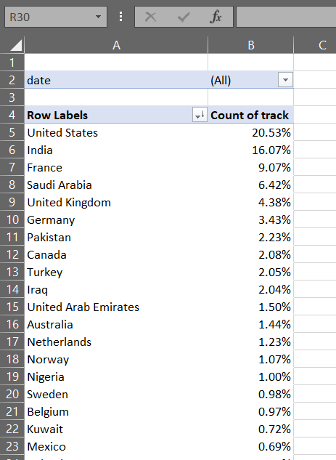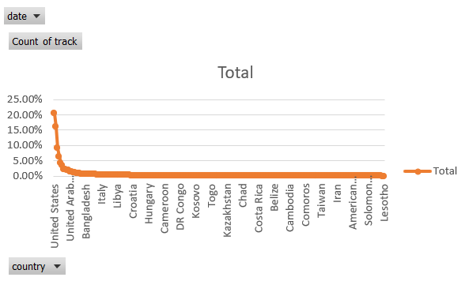

Problem 2: Best Traffic Source
I analysed from where the highest website traffic is coming. A large number of visits come from Unknown location (possibly due to tracking limits). Among known cities, the highest traffic comes from Jeddah, Riyadh and Hyderabad. These locations bring the most visitors to the website.
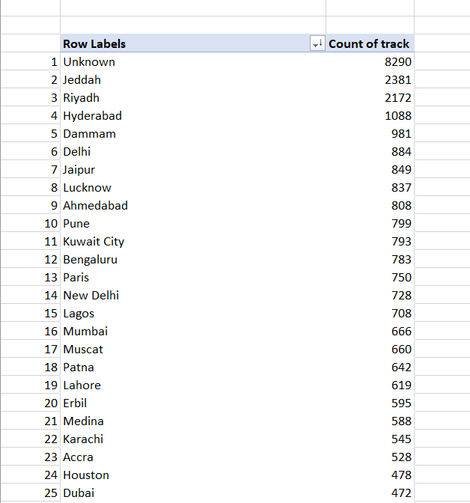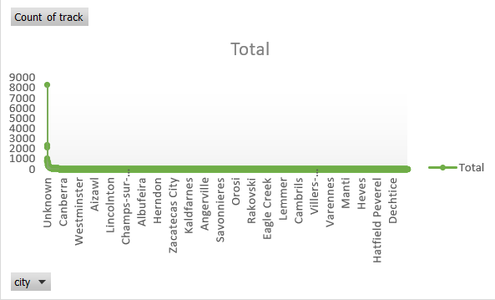

Problem 3: Daily Traffic Trend
I v checked how website traffic changes day by day. Around 14K users visit the website daily. Traffic is mostly stable, but one day, traffic increased to around 14.2K and next day, it dropped back to around 14.8K (normal level). This shows there are small daily fluctuations, but overall traffic is consistent.
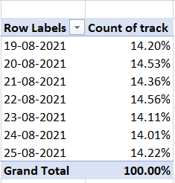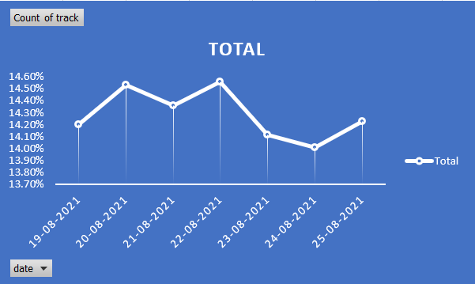

Recommendations:
- Focus marketing campaigns in US and India for better conversions
- Improve tracking to reduce unknown traffic sources
- Monitor daily traffic to identify sudden spikes or drops

